Odd Semester (2020)



**BINUS UNIVERSITY**

**BINUS INTERNATIONAL**

**Assignment Cover Letter**

**(Individual Work****)**

|  |  |  |  |  |  |  |  |  |
| --- | --- | --- | --- | --- | --- | --- | --- | --- |
|  | | | | |  | |  | |
| **Student Information**: **Surname** | | | | | **Given Names**  **Edgar** | | **Student ID Number**  **2101699666** | |
| 1. | | **Tandiawan** |  | |
|  |  |
| **Course Code** | **: COMP6502** |  |  | | **Course Name** | | **: Introduction to Programming** | |
| **Class** | **: L1AC** |  |  | | **Name of Lecturer(s)** | | **:** 1. Bagus Kerthyayana | |
|  |  |  |  | |  | | 2. Tri Asih Budiono | |
| **Major** | **: CS** |  |  | |  | |  | |
| **Title of Assignment**  (if any) | : Shooting game | |  |  | |  | |  | |
| **Type of Assignment**    **Submission Pattern** | **: Final Project** |  |  | |  | |  | |
| **Due Date** | **: 6-11-2016** |  |  | | **Submission Date** | | **: 6-11-2016** | |

The assignment should meet the below requirements.

1. Assignment (hard copy) is required to be submitted on clean paper, and (soft copy) as per lecturer’s instructions.
2. Soft copy assignment also requires the signed (hardcopy) submission of this form, which automatically validates the softcopy submission.
3. The above information is complete and legible.
4. Compiled pages are firmly stapled.
5. Assignment has been copied (soft copy and hard copy) for each student ahead of the submission.

# Plagiarism/Cheating

BiNus International seriously regards all forms of plagiarism, cheating and collusion as academic offenses which may result in severe penalties, including loss/drop of marks, course/class discontinuity and other possible penalties executed by the university. Please refer to the related course syllabus for further information.

# Declaration of Originality

By signing this assignment, I understand, accept and consent to BiNus International terms and policy on plagiarism. Herewith I declare that the work contained in this assignment is my own work and has not been submitted for the use of assessment in another course or class, except where this has been notified and accepted in advance.

Signature of Student: (Name of Student)

1. Edgar Tandiawan

**“Shooting Game”**

**Name :Edgar Tandiawan**

**ID :2101699666**

1. **Description**

**Function:**

This game was made with the intention of making other people relieve from their hard days or stress and just chilling while playing the game, the game was made only for entertainment purpose and for fun

**II Flow Chart**

After finish, another story will pop out

Main arcade (endless)

Main

Menu

Start

The game begin

It will print out the first story

It will print out the first story

Arcade

Exit

**III. Explanation of Each function**

1. **Class mainscreen ():**

* For the main game background image and setting resolution, game name and to load soundtrack for the game

1. **Class zombie ():**

* For making the zombie to appear in random places

**3. Class gunsound ():**

* For making the sound effect for each available weapon that can be chose by pressing spacebar

**4. Class weapon ():**

* For the font, size and the position of the text that will be put

**5. Class menulis1() and def afterstory ():**

* The font, size and position of the end story that will appear after the game has been finished

**6. Def mainstart() and def mainarcade():**

* For the main game to play, in mainstart it have a story so when it click to a certain amount it will print out the text in order and in main arcade it just play the game and count how many zombie were shot

**7. Def wepselectstart() and def wepselectarcade ():**

* In wepselectstart its for the story mode and wepselectarcade is for arcade, it is different because in the story mode on kill a few zombie but in arcade it is endless

**8. Class gunsound ():**

* For making the sound effect for each available weapon that can be chose by pressing spacebar

**9. Class mainscreen ():**

* For the homepage of the game so that people can choose either they want to pay story, arcade or want to exit and the soundtrack that will be played during the time and it is in different file so that it can be import

**10. Class menulis() and def story():**

* The font, size, and position of the story for the story in the beginning and def story is the word that will appear before the game

**11. Def menu():**

* For the option that were given and became the connector for all the classes and the function so it can work

**IV. Coding**

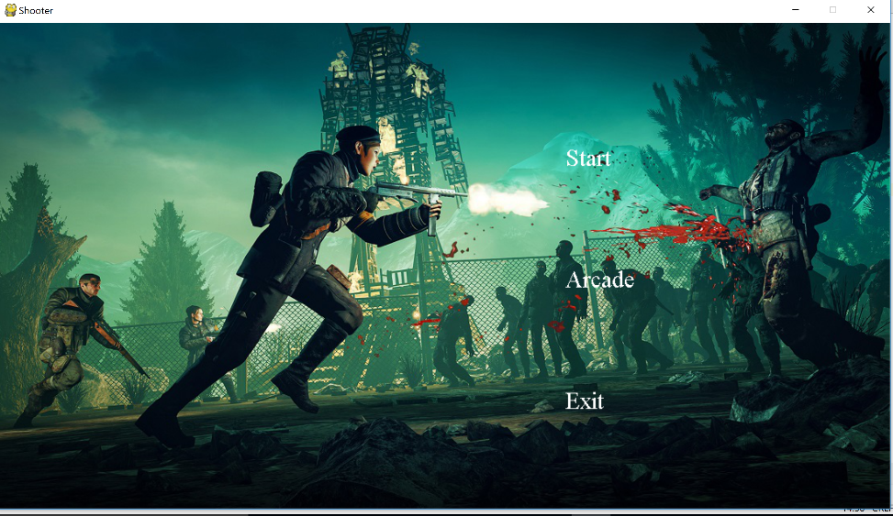

In this part of page, the class mainscreen begin to do the job to provide background image and def menu to write the word in the picture so it can continue to the next phrase

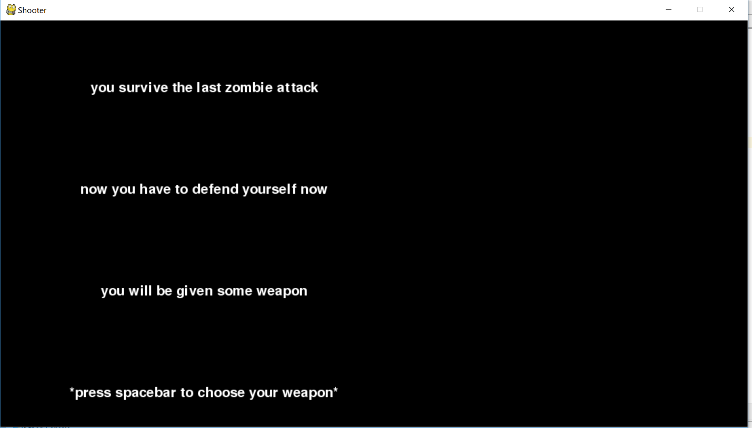

This part is where class menulis make the font, size and the position in coordinate x and y to put the word and I use def to write the word and I just make screen.fill ((0,0,0)) for some black background and after the story finished, it will change into the main game

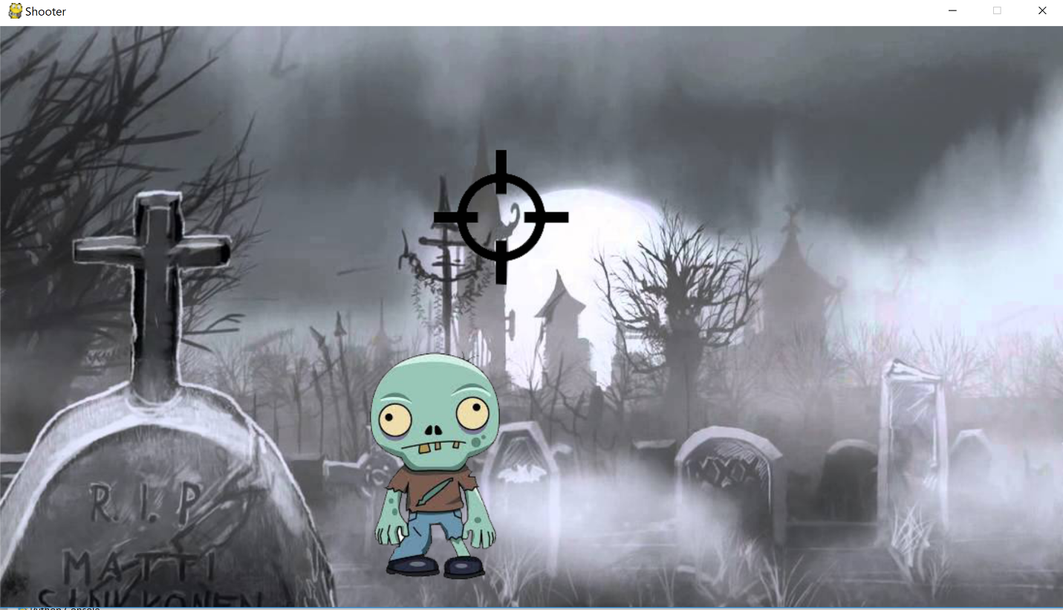 This part is where I use class aim, class main, class gunsound to produce the sound, class zombie to make it appear randomly and def mainstart to make it all work in this page including changing cursor to an image and change weapon with using spacebar.

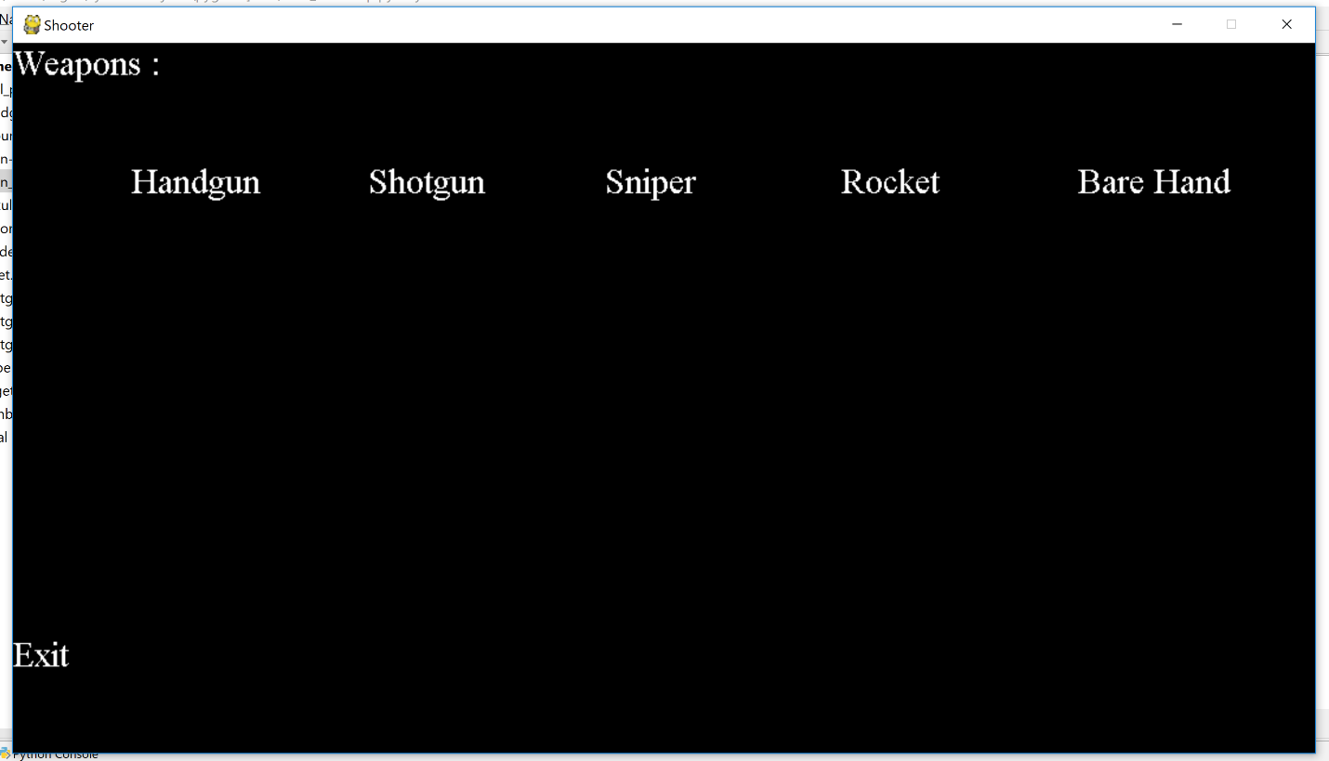

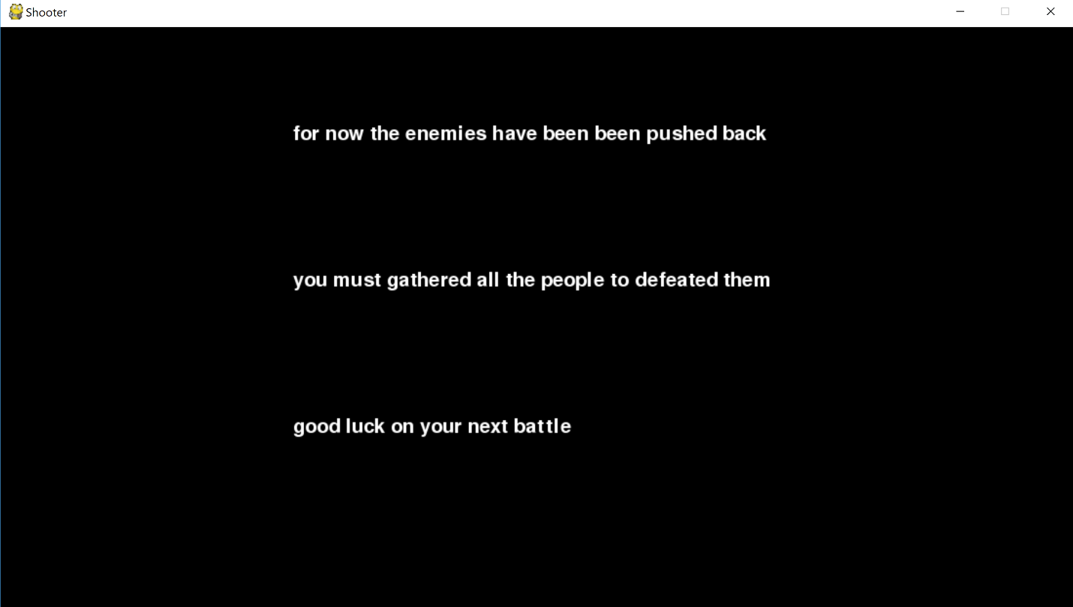 This is the option that triggred by spaing spacebar in main game and in this part, we can choose from 5 weapons that available and every weapon make different sound and using class wepselectarcade, wepselectstart, and class weapon to set the font and position

This part, class menulis1 still in use but the def is def afterstory and the principle is the same as the story and in this part the story mode is over

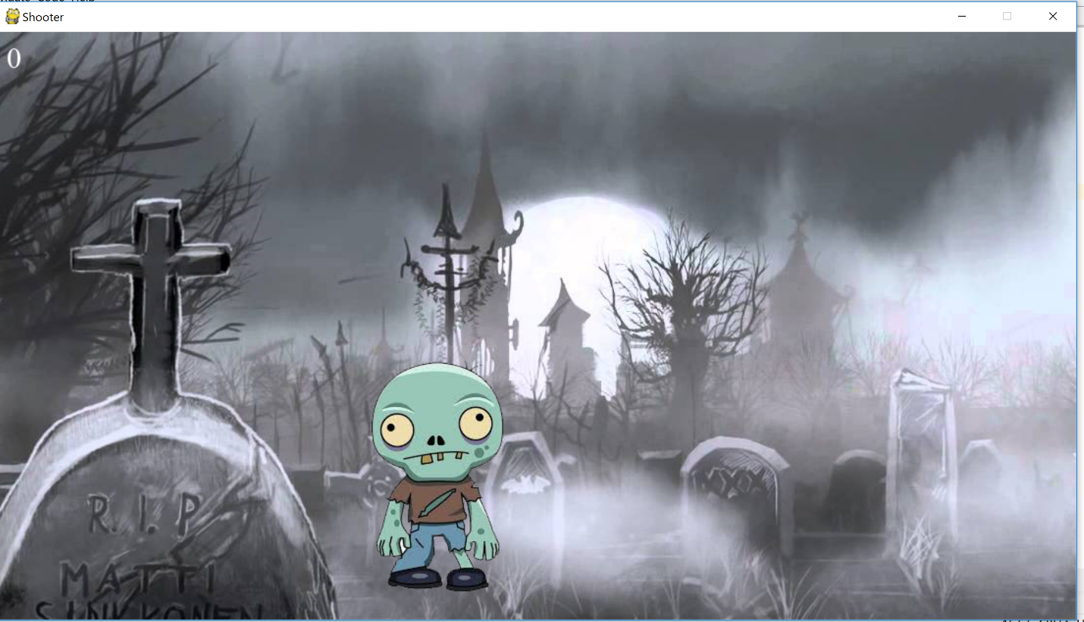 This is the additional part and use class mainarcade, class wepselectarcade and class score to record the number of zombies killed